**ASSIGNMENT-1**

**TEAM MEMBERS**

AISHWARYA LAKSHMI.R

ABITHA N

MERSCIA SERYLIN JEFY .A

SHRINIDHI .N.A

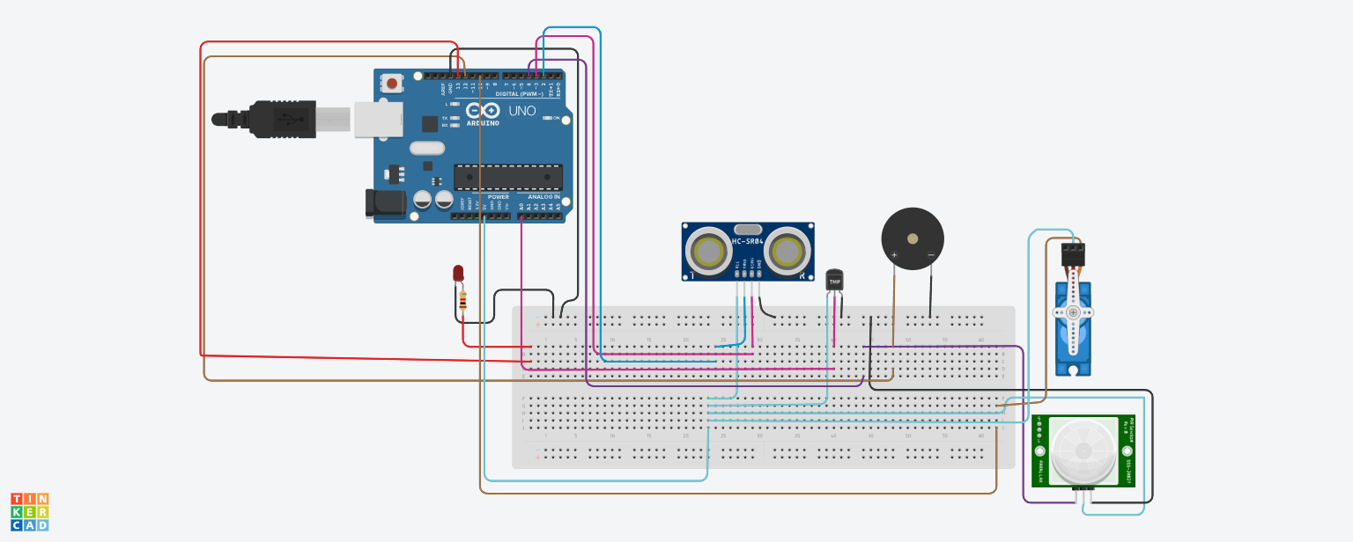

**Code:**

#include <Servo.h>

int location = 0;

int i = 0;

int j = 0;

Servo s;

void setup()

{

Serial.begin(9600);

pinMode(4,INPUT);//PIR sensor

pinMode(13,OUTPUT);//Red LED inside home

pinMode(12,OUTPUT);//Buzzer for temp

s.attach(10, 500, 2500);//micro servo

pinMode(3,INPUT); //ECHO in ultrasonic

pinMode(2,OUTPUT); //TRIGGER in ultrasonic

}

void loop()

{

int n=digitalRead(4);

Serial.println(n);

if(n){

Serial.println("MOTION DETECTED!!!");

location = 0;

for (location = 1; location <=180; location+=60){

s.write(location);

delay(100);

double a=analogRead(A0);

double t=(((a/1024)*5)-0.5)*100;

Serial.print("TEMP VALUE: ");

Serial.println(t);

if (t>100){

for(int j=200;j<220;j++)

{

tone(12,j);

}

delay(1000);

noTone(12);

}

digitalWrite(2,LOW);

digitalWrite(2,HIGH);

delay(1000);

digitalWrite(2,LOW);

float dur=pulseIn(3,HIGH);

float dis=(dur*0.0343)/2;

digitalWrite(13,LOW);

if (dis<20){

Serial.print("Distance: ");

Serial.print(dis);

Serial.println(" cm");

digitalWrite(13,HIGH);

}

}

digitalWrite(2,LOW);

digitalWrite(2,HIGH);

delay(1000);

digitalWrite(2,LOW);

float dur=pulseIn(3,HIGH);

float dis=(dur*0.0343)/2;

digitalWrite(13,LOW);

if (dis<20){

Serial.print("Distance: ");

Serial.print(dis);

Serial.println(" cm");

digitalWrite(13,HIGH);

}

}

delay(1000);

}